TY B.Tech. (CSE) – II [ 2023-24 ]6CS371 : Advanced Database System Lab.Assignment No. 2

Name : Sourabh Yashwant Chaugule

PRN : 21510037

Batch : T 7

1. **MySQL / PSM Review :**

**Objective:**

The objective of this MySQL/PSM review is to demonstrate database manipulation using MySQL syntax and Persistent Stored Module (PSM) procedures.

A: Creation of a table named test_table with specified columns and development of a PSM procedure to insert 50 records including the current date in the table.

B: Creation of a products table with sample data and implementation of a PSM procedure with two user-defined values(X and Y). The procedure will increase the price by X% for a product in Y.

**Introduction :**

This MySQL/PSM review demonstrates hands-on examples of working with MySQL databases and Persistent Stored Module (PSM) procedures. Task one involves creating a table and developing a procedure for efficient data insertion. Task two focuses on a products table, showcasing a PSM procedure that dynamically adjusts prices based on user-defined percentage increments and category selections.

a) Create a table called test_table with 2 columns RecordNumber  
(type : Number(3)) and CurrentDate (type : Date)). Write a  
procedure in PSM which will insert 50 records into test_table. Insert  
the current date value into the table.

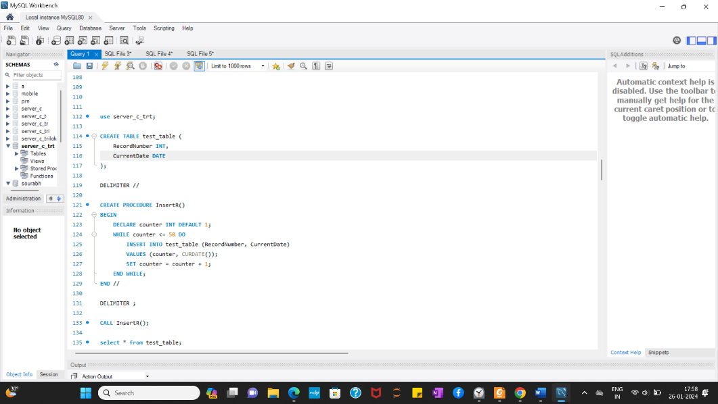

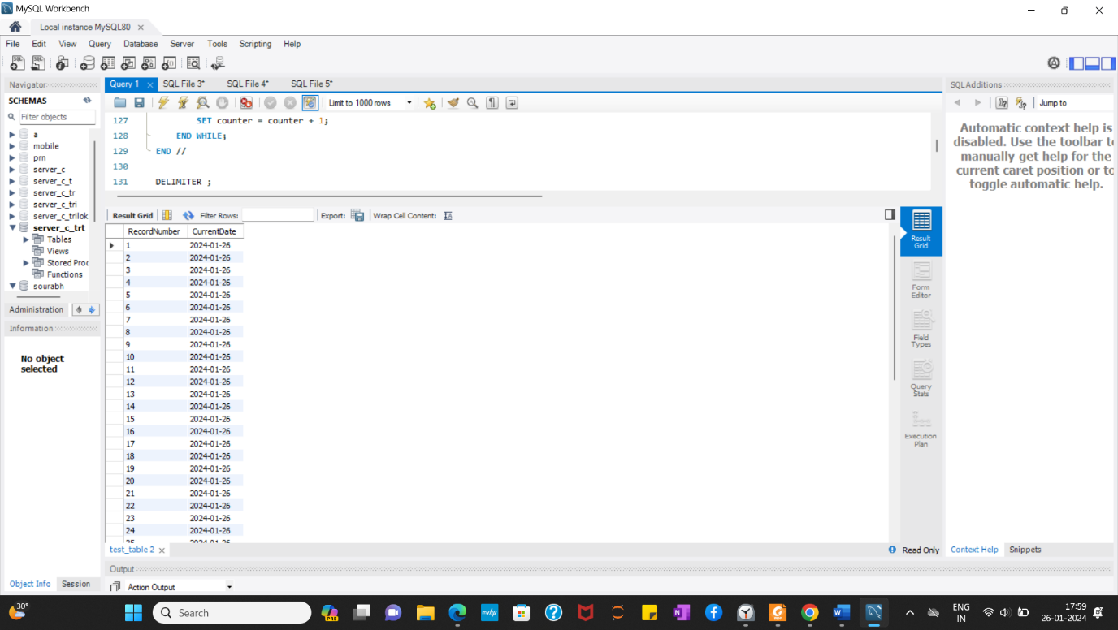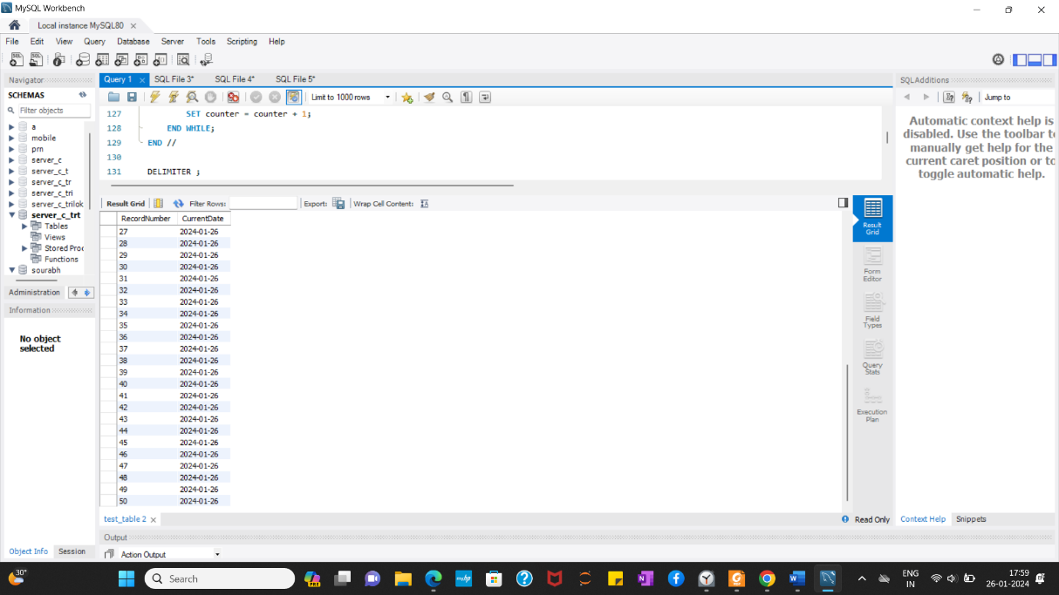

b) Create a products table products(ProductID number(4),category  
char(3),detail varchar2(30),price number(10,2),stock number(5)).  
Insert the sample data.  
Write PSM procedure with two arguments **X** & **Y** which will increase  
price by **X**% for all products in category **Y**. X and Y will be given by  
user.

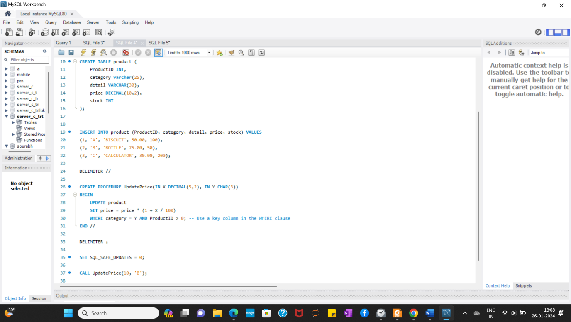

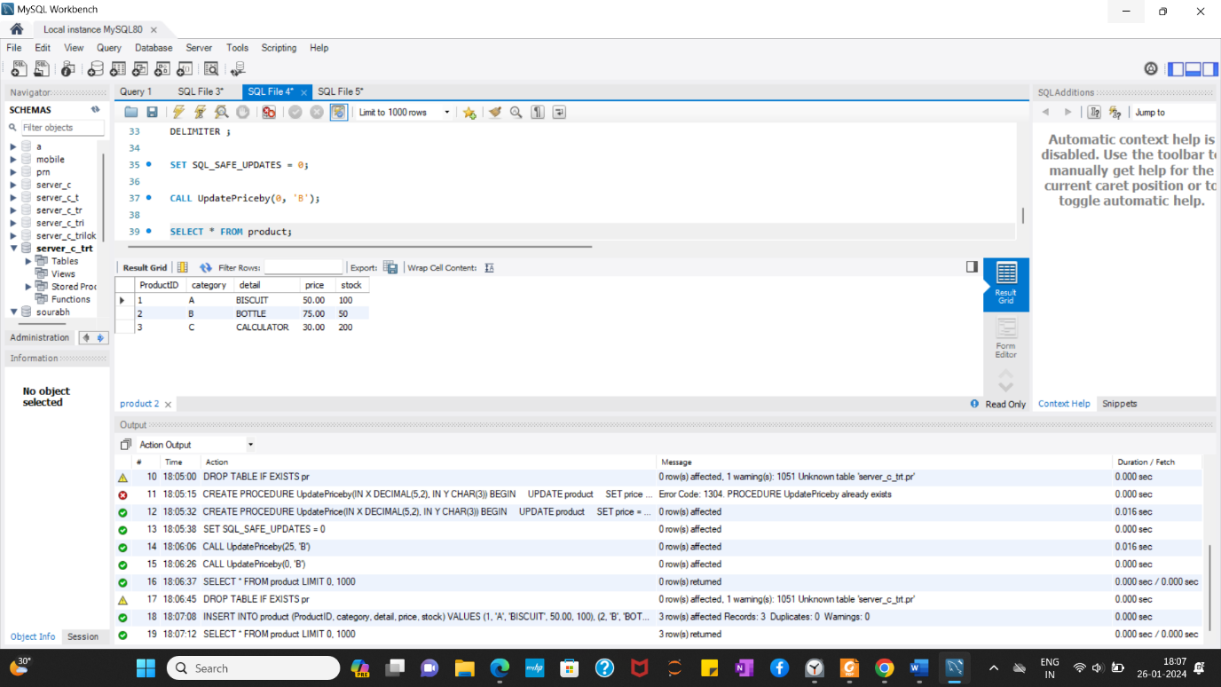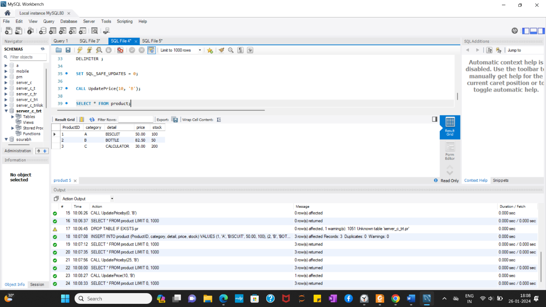

1. **Object Relational Databases:**

**Objective:**

Here we are creating and utilizing user-defined objects and types in a database context.

A: Design an Object Table with a "name" field and a member function "countNoOfWords" to determine the number of words in the "name" field. Demonstrate functionality with various data inputs.

B: Develop an Address Type with attributes like address, city, state, and pincode. Implement methods to extract addresses based on a provided keyword and to count the number of words in each field.

C: Introduce a user-defined data type, course_Type, comprising attributes like course_id and description. Create an object table based on this type and insert rows into the table.

**Introduction:**

In this series of tasks, we explore the creation and utilization of user-defined objects and types within a database. The initial task involves an Object Table with a "name" field, equipped with a function to count the number of words in this field. After that an Address Type is defined, incorporating methods for extracting addresses based on a keyword and counting words in specified fields and at last we use custom data type, course_Type, is introduced to establish an object table and insert rows. These tasks collectively provide a hands-on exploration of advanced database features.

a) Create Object Table containing field “name” of size 50  
characters and member function “countNoOfWords” which  
returns the no. of words in “name” field.  
Demonstrate the working by entering different data.

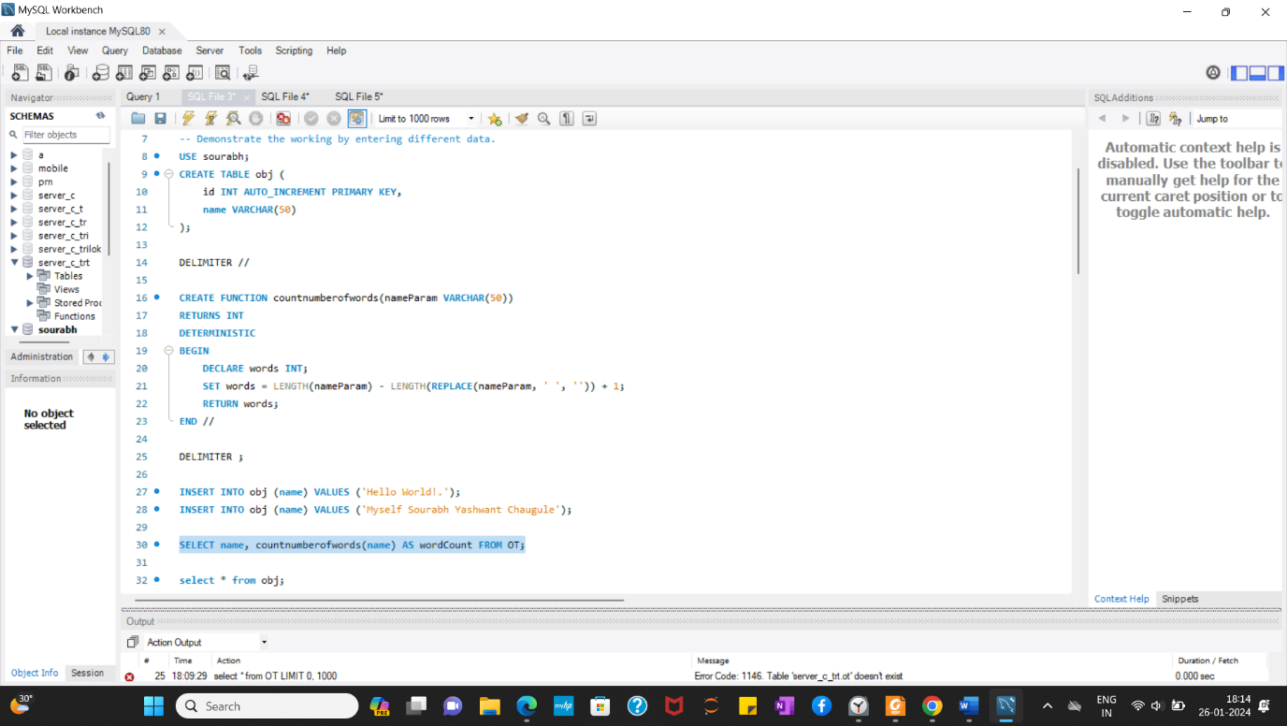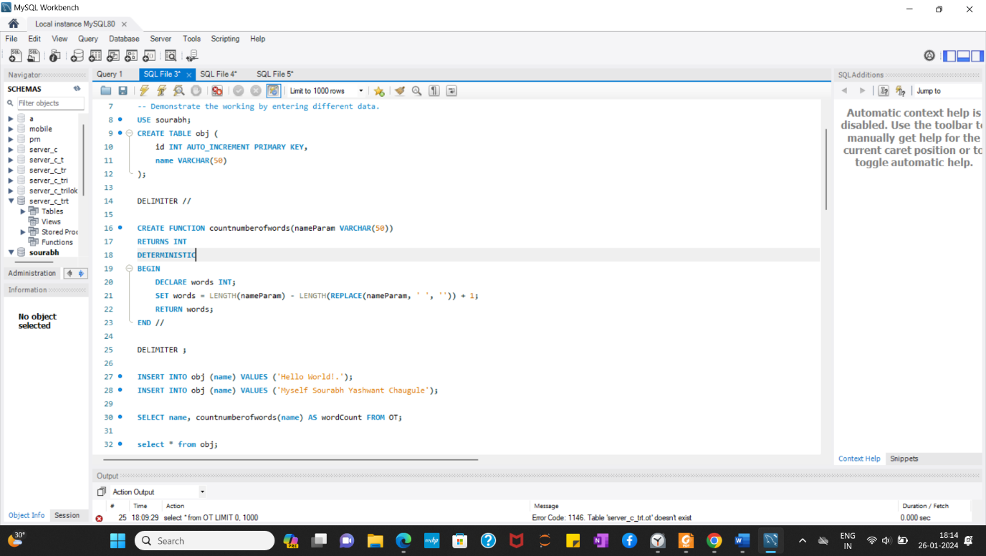

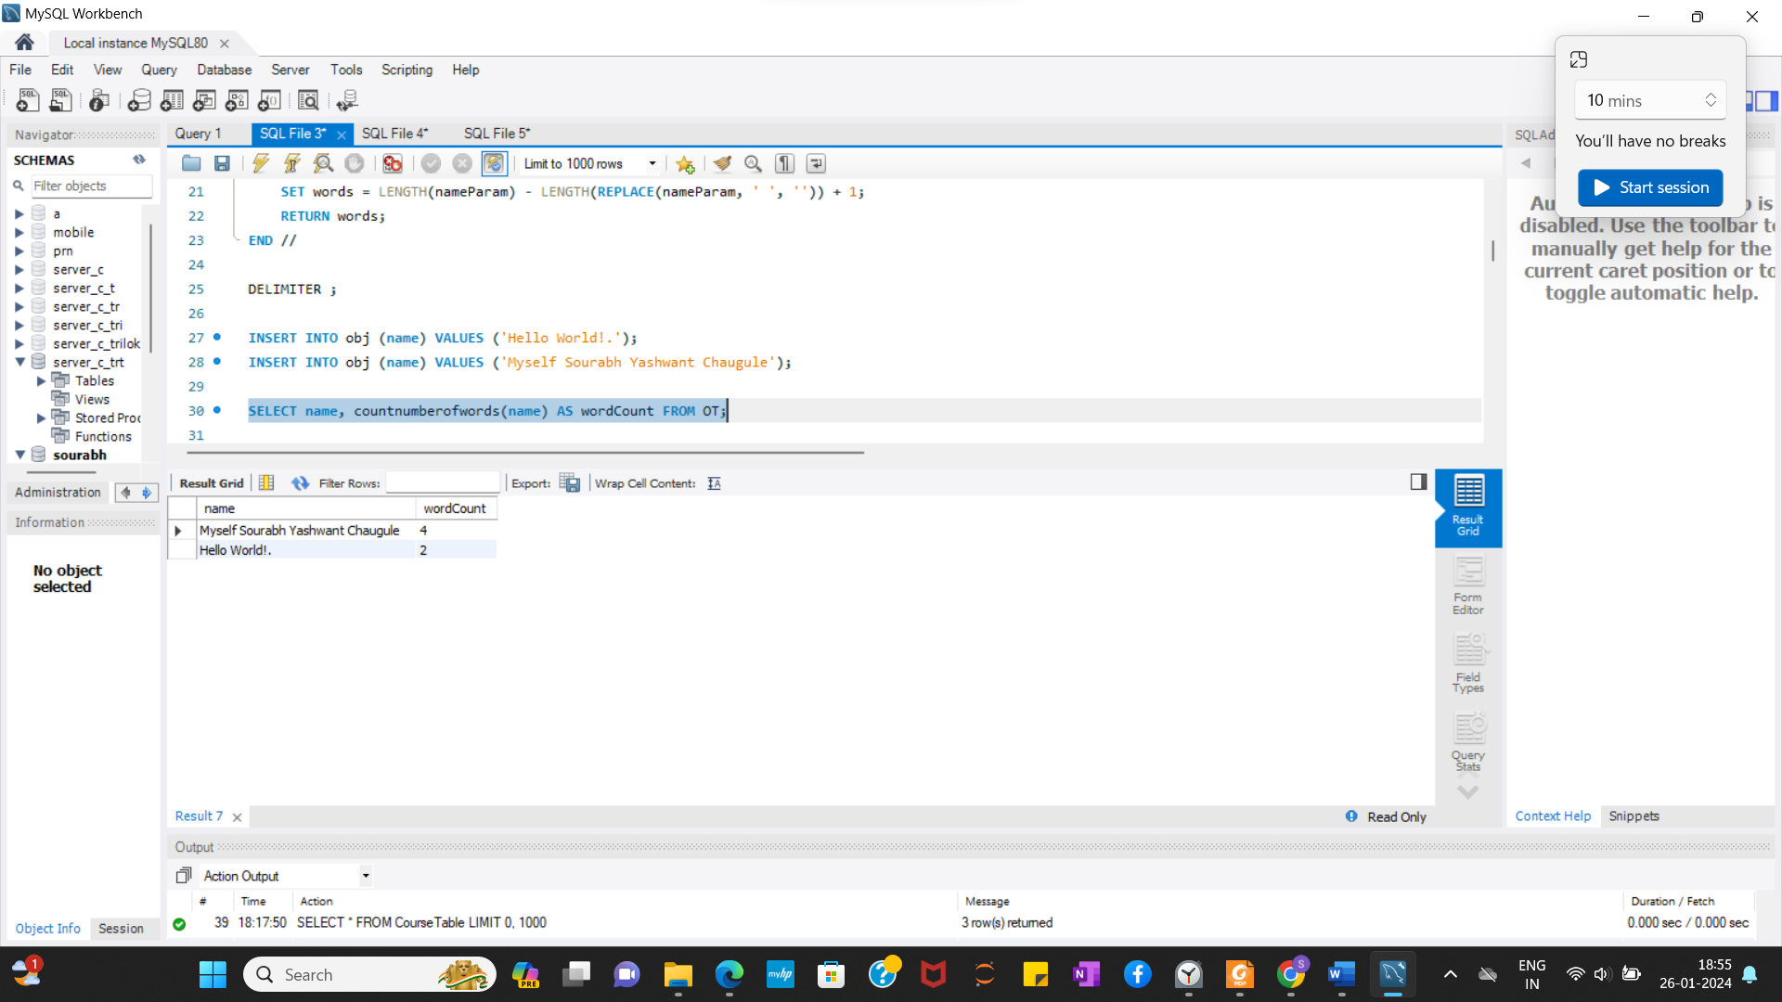

b) Create an address type with the following attributes : address,  
city, state & pincode. Include the following methods  
i. to extract the addresses based on given keyword.  
j. to return the no. of words in each given field (method  
should accept the name of attribute/field)

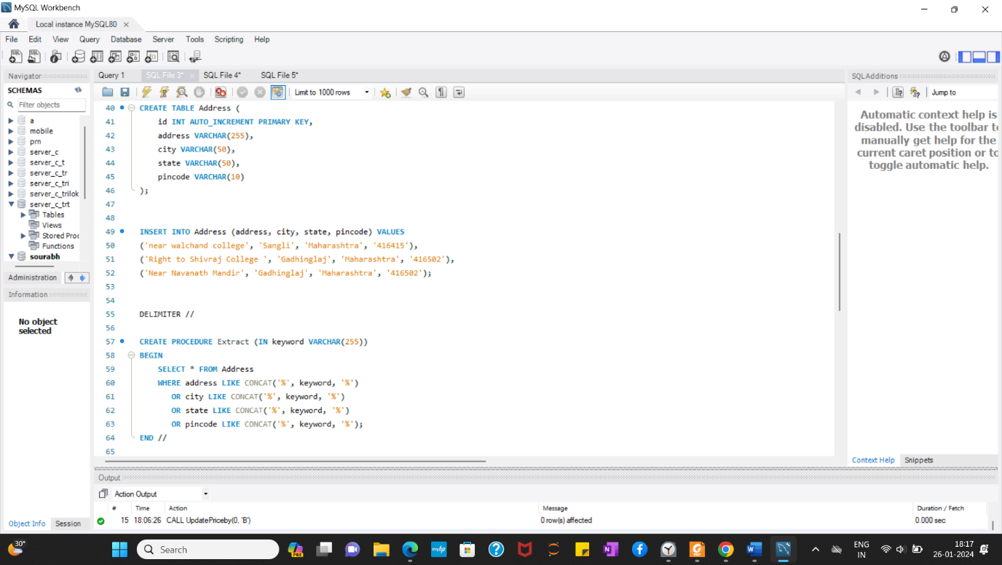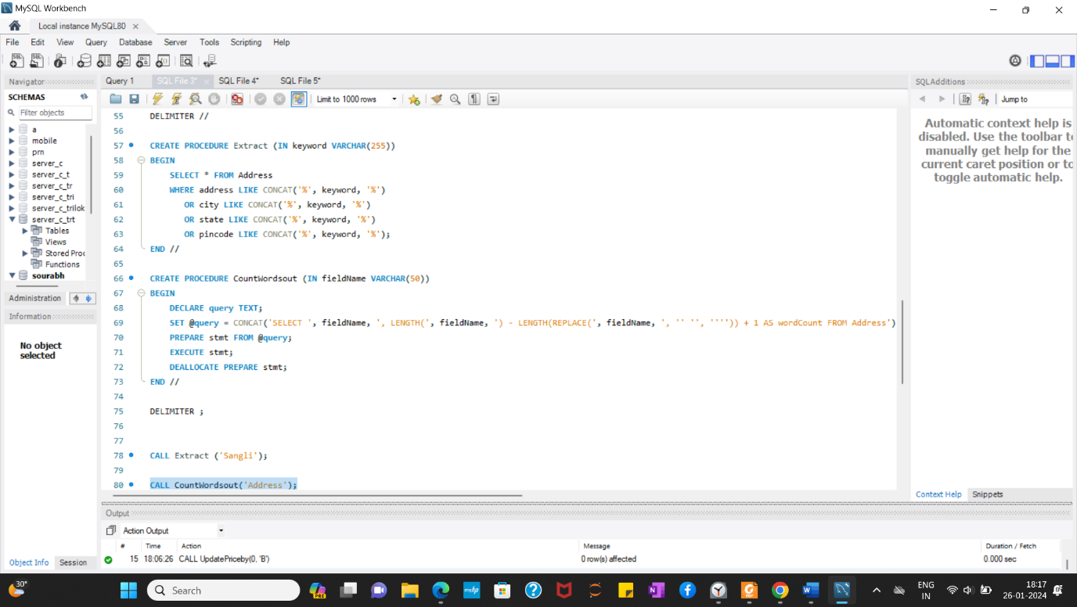

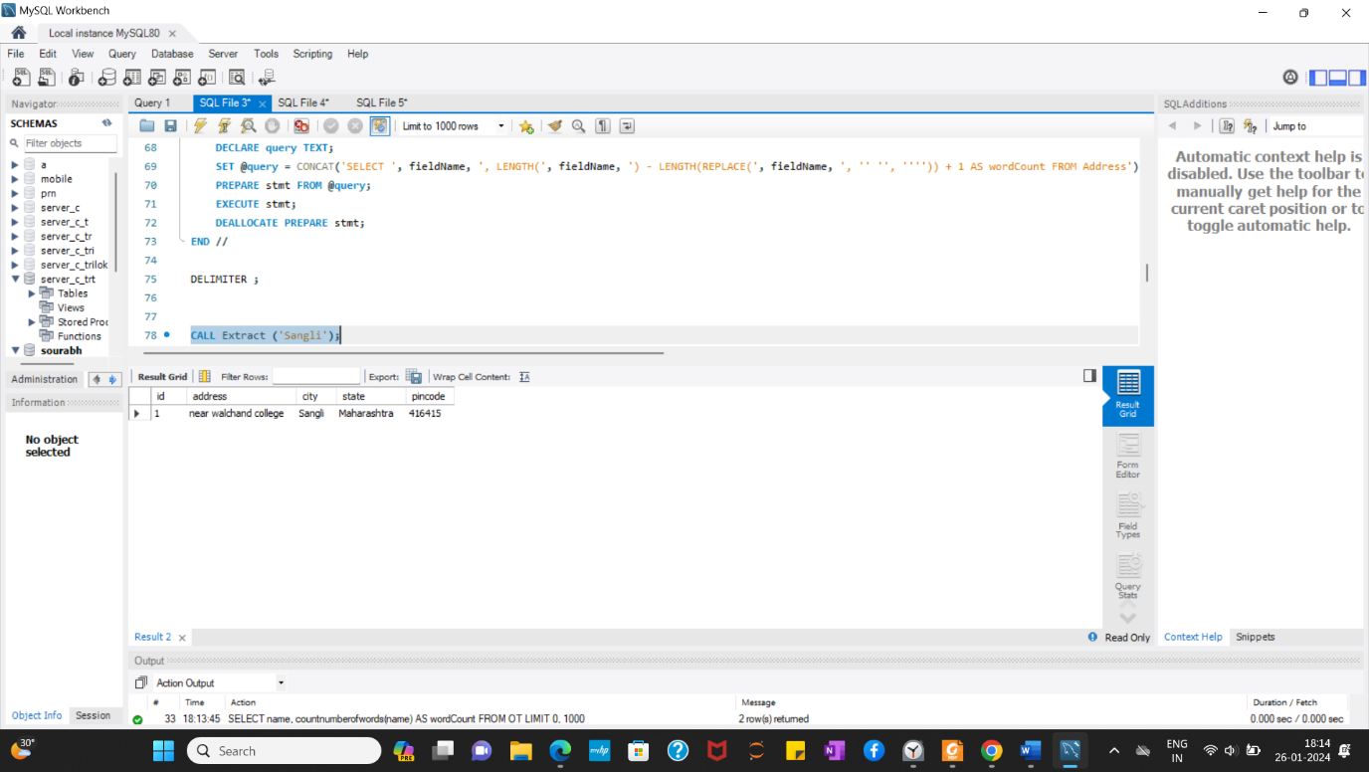

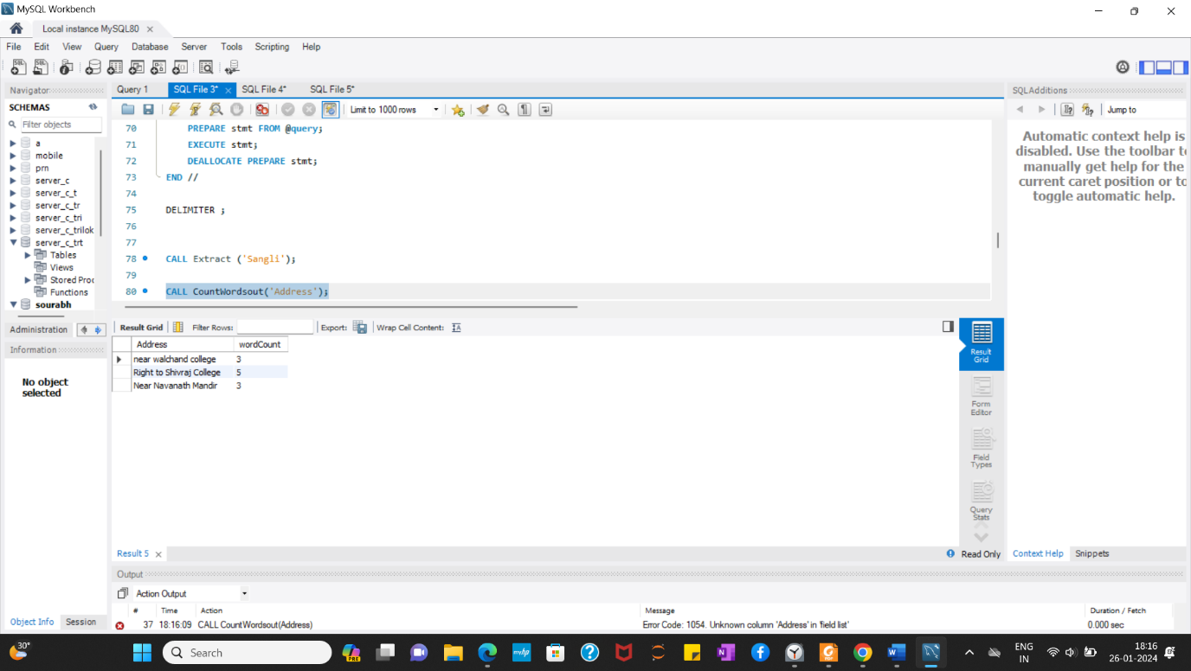

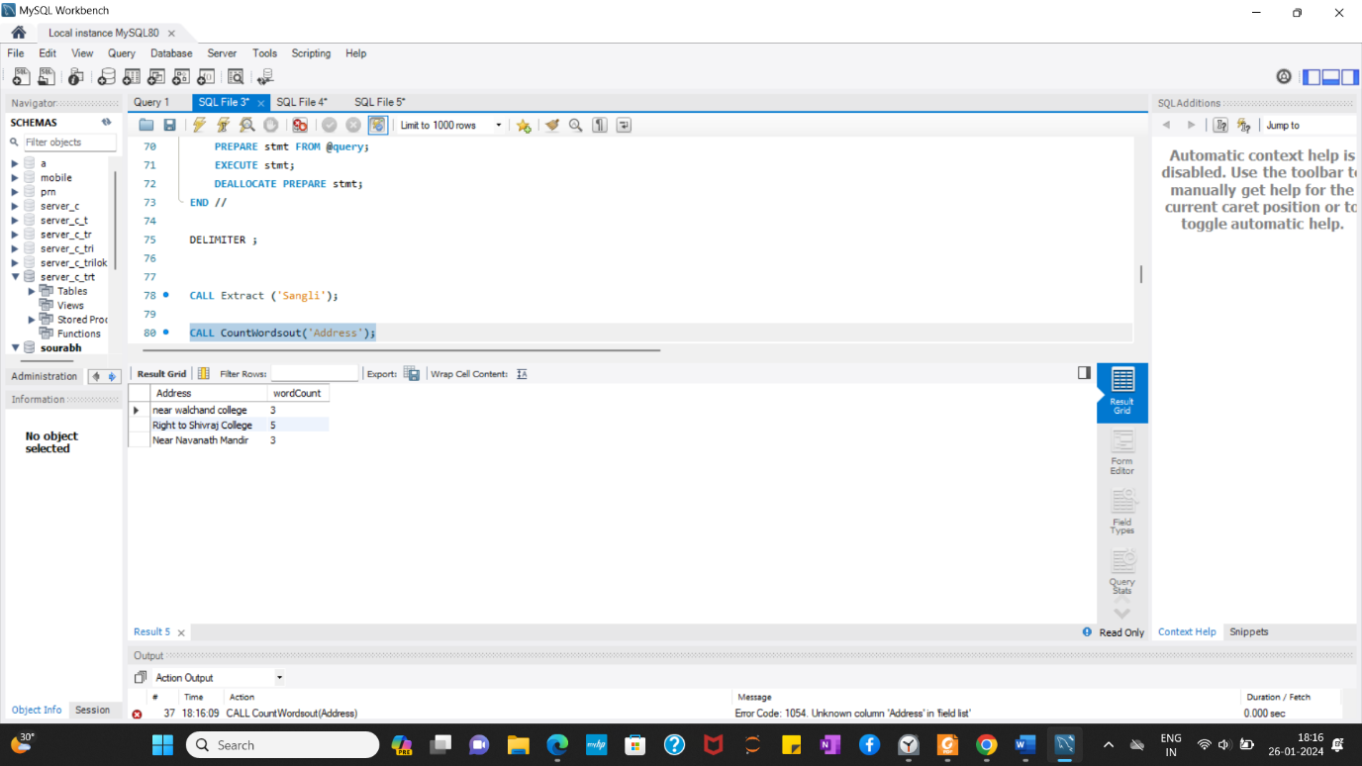

c) Create a user defined data type course_Type with 2 attributes  
course_id, description :  
i. Create an object table based on the type created.  
j. Insert rows into the table  
Demonstrate the working with different data sets

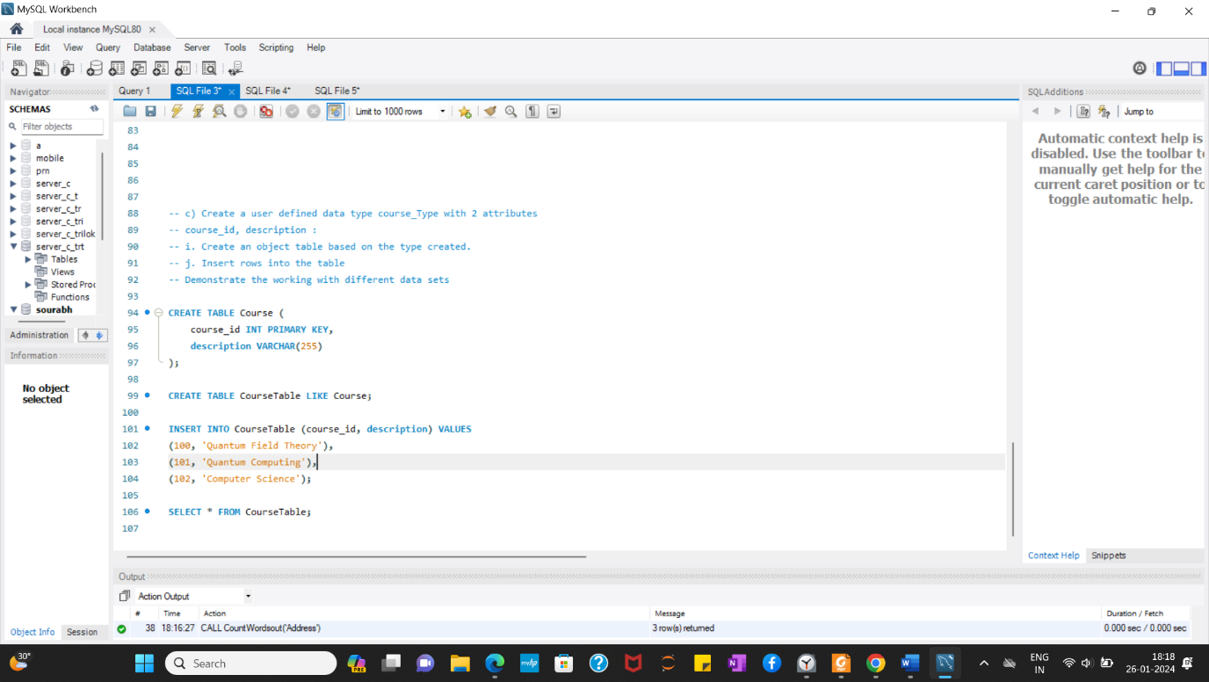

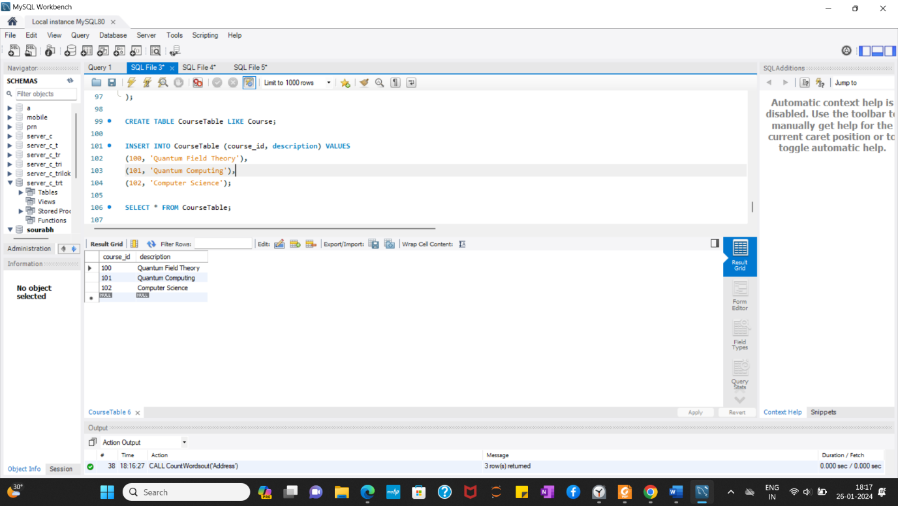

Conclusion : Here we studied about PSM and Object Relational Database.